

Whatever else Christmas does, it provides a chance to express unbridled worship to our King. Jesus is not in a time warp that keeps Him stuck in irrelevant "sweet baby Jesus" mode. Even though the Word became flesh, too many Christians keep Him tucked in a manger.

If we can see beyond the Bethlehem stable, we will do the same. It won't be a sentimental nostalgic worship. It will be true worship. We won't find ourselves standing over a straw-filled feed box cooing over a baby; we'll be prostrate on our faces before our King. That's what happens when we . . .

***Truly*** ***Worship Him.***

The pathway of worship was opened to us in a hillside cave just outside of Bethlehem, and it has traversed 2,000 years of valleys, streams, oceans, cities, and nations.  No matter where one first steps onto that pathway, it always leads to Bethlehem.  *"The Word became flesh and dwelt among us; and we beheld His glory . . ."*

**Merry Christmas and a Wonderful New Year!**

Bob and Jo Ann Tolliver

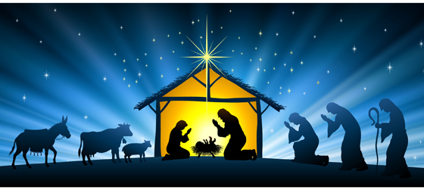

Dear Friends, Family, & Partners:

Whether we read Luke's record in Bethlehem, Matthew's account in Nazareth, Paul's narrative in Romans, or any of the encounters people had with Jesus, there was one uniform response –

***They Worshiped Him.***

