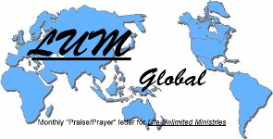 LUMglobal #114
February 22, 2014

Dear Friends, Family, and In-Pact Partners:

Wow! It is hard to grasp all that God has done for us these past 34 years since Life Unlimited Ministries was founded in 1980. The asterisks (*) below show a partial list of the countries we've been privileged to go to in serving Him, training believers, and sharing the Gospel. The Plus signs (+) also represent some of the count-ries where people through our ministry have gone to or have used social media in which to minister to others. And, that doesn't count the 37 states or other countries we've been in. He is an amazing God, He expressed amazing grace through His Son, and He has led us on an amazing journey. We are so grateful!!!
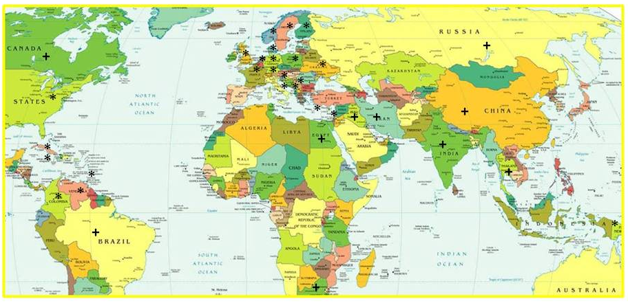
And that isn't the half of it! We now find ourselves in something of a "holding pattern", wondering where the Lord will have us land next. We're both convinced that "something is afoot" and excited about what it may be.

So much is going on globally that it is as if the world is coming apart at the seams. Additionally, the gap between churches playing the game and those experiencing the amazing power of God ever widens. Add to that the weather extremes and the revived jabber about global warming (now conveniently relabeled "Climate Change"), and it doesn't take much alertness to realize that we are seeing Bible prophecy increasingly unfold before our very eyes. We feel God's plan for us in days to come has been choreographed with that in mind.

Sadly, many believers simply turn away with a sense of fatalism that they mistakenly think is faith, concluding that "whatever will be, will be", so don't lose sleep over it; instead, "eat, drink, and be merry, for tomorrow . . . " All of this makes us feel it's no time to slow down, but do just the opposite. Our Europe trip last summer has simply intensified what we are feeling, and we hope to adequately articulate that to you in this report letter. We have never felt such a sense of urgency and drivenness as we do today.
Last Summer as we prepared for that trip, God put in our hearts the slogan, "Compelled to Go!", with the conviction that, even though it would be costly, inconvenient, long, and tiring, we knew we had to go. It didn't take us long to see that we not only did the right thing, but the slogan itself was for much more than just that three-month trip. It was to be a description of a new chapter in our lives and ministry.

Then in January, God gave Bob a theme or motto for this new year. . . .for us and for all believers . . . .

"2014 – A Year Of Courage, Boldness, and Confidence!"

So, with that in mind, we share the following update & thoughts with you, asking that you pray with & FOR us.

What's Been Happening With Us: This has been an unusually sparse winter since our return from Europe October 31st. We have had only one Bible conference since then just before Thanksgiving, and two preaching opportunities last Sunday and Monday at the Barry County Evangelism Conference. Even though there are several pastorless churches, we've not had a single request to minister anywhere.

This might be an exasperating circumstance for many folks, but we actually have real peace in the matter because we've gone through situations like this before, and in each of them we found that God had something pretty exciting for us in the future. We feel the same way now, but don't know what His plan is.

We wish we could be more specific about the future, but do know that the Lord keeps assuring us that something significant is in the future and that, until we know what it is, we are to be faithful where we are, continue with our writing and using social media to encourage and train others, and get things in order around the house by disposing of unnecessary things, redecorating, and repairing.

So, we will continue preaching and conducting conferences as the Lord opens the door, and will continue preparing for a return trip to Europe probably around the end of July or first of August where we will again help "F", "H", "M", and others with Farsi work and any other ministry that might be needed.

We ask you to pray with us about all of this, that we'll have real clarity. One thing the Lord has shown us is that we are far from any hint of "retirement", that we are still being "Compelled To Go", and we are to be "Bold, Courageous, Fit, and Confident."

With all of this in mind, we want to share about some "new" things the Lord has us involved in at this time, asking you to pray with us about these areas, and that the people who are leading these ministries will have great success and see much fruit. It is possible that one or more of these may be factors in future ministry.

Ukraine: Because things have changed so quickly, Bob has rewritten this part of the letter four times. Clearly, our attention is focused on it all, and since Saturday, our concern has been alleviated with joy and cautious hope. We have hundreds of friends living there, and many ministries with whom we worked are located there as well. We have been getting e-mails or Facebook messages almost hourly about the situation.

During the widespread demonstrations, several regional governments were toppled, and in some cases police ended up supporting the demonstrators. Several pro-Yanukovich Members of Parliament and city or region officials left the Party of Regions and joined the pro-west anti-corruption demonstrators. The Parliament overwhelmingly voted to return to the 2004 Constitution, stripping most of the presidential powers from the presidency. Yanukovich, refusing to resign, was ousted as President after he left Kiev, and impeachment has been approved. The Prime Minister, Speaker of Parliament, and Interior Minister have all resigned and have been replaced. Yanukovich supporters have gathered in Kharkiv, and met with Russian leaders. Yulia Tymeshenko is also out of prison, spoke at a rally in Maidan Saturday night and assured the crowd that she would be a candidate for President in May elections.

No one knows the future for Ukraine. It could remain united, or it could split or have some regions break away through cessation. Please pray for Ukraine. The people have a very long path ahead of them, and only the Lord knows what will happen next, and whether or not this attempt to root out corruption will succeed.
History of Ukraine: Recently Bob wrote an article about Ukraine's centuries-long history in one of his "Shoulder To Shoulder" letter. If you'd like to learn more about the 5,000+ year history and struggle of the Ukrainian people, you can go to it at this website: http://www.associate.com/groups/shoulders/0::970read.html.

Farsi Update: Unfortunately, we don't have very much to share about the Farsi work; between workloads, schooling, and the demonstrations in Ukraine, communication between them and us has been scarce. Apart from a few short e-mails and one Skype conversation a month ago with "M", we haven't heard much. We know nothing that is going on in Sweden as "H" leads there. We know that in Giessen, the three weeks "M" and his family spent there was highly productive as they met with local leaders and with the immigrants. The German church is open to future developments in time, and we think the Farsi group is focusing more on local small groups and leadership development.

We also understand that the group in Kiev remains very small, but that "M" and "M2" are working feverishly with Emmanuel Television Studios (CBN) in producing teaching and evangelism videos for the Farsi website, often spending 8 or 10 hours a day in the studio. We also understand that the demonstrations in Kiev have really limited their ability to move about safely. At one time police had actually set up traffic barricades even in "M"'s town nearly an hour from downtown Kiev and have been searching vehicles and questioning drivers. Jo Ann got an e-mail from him Friday in which he indicated that things were very difficult and the shelves in grocery stores are often empty. There have been times when there wasn't even any bread available.
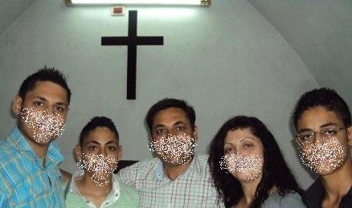

URGENT NEED! For more than a year Bob has had a Syrian pastor
in his "Preachers Only" Facebook group of over 600 members. He had
not heard from " S" for several months and was concerned for the
welfare of him & his family. They had been "on the go" from radical
Islamic groups for some time. Bob heard from him and found that he
has fled to Russia, along with his brother and his family. "S"'s wife
and three sons are still in Syria.

Bob shared with him about the possibilities in Germany, and we'd like
to help him get to Giessen if possible, where he could find asylum, try to get his family to join him there, and also have an opportunity to minister to the thousands of Arabic speakers in Germany. However, for that to happen, we need at least $1,000 for a plane ticket from Russia. We are asking you to help us raise the funds, and to do so quickly. As always, you can make the check out to Life Unlimited Ministries, put "Arabic Ministry" on the Memo line, and then mail it to us. Please help if possible. If you have questions, contact us directly.

Sergey and Siberian Buryats: In 1995 we made our first of seven subsequent trips to Ukraine to teach at St. James Bible College. Jo Ann taught Henry Blackaby's study, "Experiencing God" to two Freshman classes, and Bob taught his seminar on reaching cities to graduating seniors.
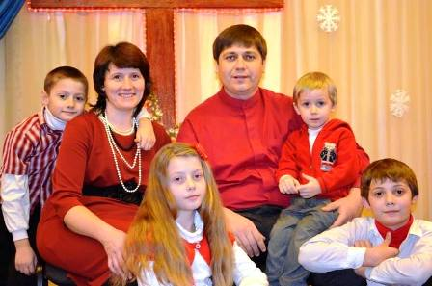
The Senior Class President was Sergey Lyakov from Brobrinets in
south central Ukraine.

Sergey now lives in Ulan-Ude in Russia, just north of Mongolia where
he pastors a Buryat church that is aggressively proclaiming the Gospel
and planting house churches. About a year ago we reconnected with
him, and now try as much as possible to serve and encourage him.
We feel he is, in a way, an extension of our ministry, and praise God
for him and what he is doing in reaching people in a difficult ministry.

In a letter last month, he wrote, "Our church is to outreach non-believers and make of them Christ's disciples. Also we develop home groups at our church, we have outreach team that goes out weekly to different villages with a purpose of evangelism. There's a strong resistance such as: climate, severe frost outdoors, human's hard-heartedness, strongholds of Buddhism and Shamanism… With God's help we're trying to move forward and make progress. If you will … pray for us we would be very grateful to you. ---- Pastor Sergey"
Timur in Russia: One of the first people we worked with when we first moved to Kiev 11 years ago was a Uzbek Christian, Timur Atabekov. Fluent in English, Timur was living in Kiev as a professional translator. Single at the time, Timur was actively involved in ministry and working with different ministries including Living Vine IBC where we first served. Following the beginning of KIBC, he
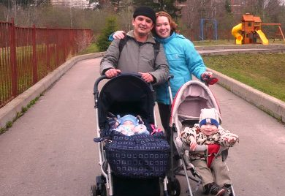
became more involved at Living Vine and served as their missionary.
Timur & his family now live in Vladimyr in central Russia where they
work with some local Russian churches and share the Gospel with
Russian-speaking Muslims. They especially seek out people from
his home country of Uzbekistan. He also is seeking to disciple and
train leadership in efforts to reach unbelievers. He and Bob corres-
pond on a pretty regular basis, and they also try to talk together via
Skype, and are planning to meet on a regular basis soon..

So, What About The Future? Very good question! We really need your prayer as we try to discern. One thing we DO know -- we have no interest in sitting back as spectators in a church with nothing to do. Our hearts continue to pulsate with missions, spiritual awakening, encouraging others, and training and mentoring leaders. This letter is named "LUMglobal" for a reason; -- Life Unlimited Ministries committed to a global field.

This focus comes as no surprise to us because, following a 1990 seven week ministry in New Zealand, a pastor in 1993 told Bob that he believed our ministry would "have international implications". Two years later we made our first trip after that to Croatia. Then in 1997 the Lord put in our hearts a promise that we have never been able to shake . . .

'Ask of Me, and I will surely give the nations as Your inheritance,
And the very ends of the earth as Your possession."
Psalm 2:8

At this time, we continue our writing and encouraging people, available to minister in any setting the Lord con-firms to us. We still have a passion for students, and long to spur them on to follow Jesus and become disciple makers, wherever it takes them. We also have an almost unbearable burden for churches that are dying, stagnant, or are caught up in active fervor with little or no real fruit to show. We believe strongly in planting new churches that are modeled after the New Testament pattern and free from burdensome and often complicated systems and structures. We are wholeheartedly committed to teaching and training believers in other nations and in sharing the Gospel with unbelievers there.

While we are home and not away for ministry or for personal reasons, we will continue our writing, our ministry to others through the social media, seek out opportunities for local ministry, try to develop some video material that will let us multiply our usefulness, and do some much needed updating and repair on our home. We will also begin preparation for our return trip to Europe next summer to minister again with our Farsi speaking leaders as they faithfully serve in Germany, Sweden, and Ukraine.

Prayer Requests: Needless to say, we have some very serious prayer requests, including but not limited to . .
- Immediate funding of $1,000 to help our Syrian pastor friend, Saied, get to Germany for asylum.
- Wisdom in making right decisions regarding future ministry direction.
- An increase in our monthly support base so we can do more. We still usually come up short.
- Doors to open for conferences, revivals, seminars, etc.
- Physical energy and financial resources to do repairs and upgrading around the house.
- Spiritual insight to process and discern many, many things God has been saying to us.

Finally: Thank you beyond words for your encouragement, prayer, and financial support. Please let us hear from you and tell us what you think. We value your insight and wisdom.

In His Bond, By His Grace, and For His Kingdom
Bob and Jo Ann (The Tollivers)

