STILL

LUMglobal #116 June 4, 2014

Dear Friends, Family, and In-Pact Partners:

Greetings again from the Missouri Ozarks, where we have enjoyed beautiful Spring weather with all its variations and colors. We're praying that you are doing well and finding God's continued faithfulness in your lives. We are continuing to seek the mind of God regarding various ministry needs and possibilities, and we truly appreciate your ongoing prayer and support for Life Unlimited Ministries.

We are writing for a very special reason -- an upcoming ministry opportunity in Europe and South Asia. However, first a very brief update: ----

Since our earlier letter last month we were privileged to speak at Oakwood Baptist Church in Lee Summit, MO, and had an extraordinary experience in a church where the pastor has a powerful heart for missions and is leading his congregation to personal involvement in both local and overseas missions. It was a real treat we enjoyed thoroughly. We've also been able to attend services in our home church a couple of times, and get more things caught up around the house.

Cindy, Kevin, and Christopher (below left) are just two weeks away from returning to the States for a year. Christopher graduates from high school in Medellin (still can't believe it!) next Monday, June 9th, before they return, and they land in Des Moines the 17th. They must attend a conference in Springfield, MO, beginning that following week-end, so we'll get to spend some time with them as they spend the nights with us.

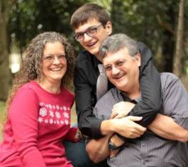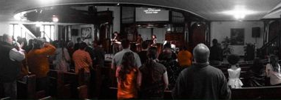

On June 22nd we will speak at Bales Community Church, a merge of Bales Baptist Church and Living Faith KC with whom we worked for a year and a half. We are anxious to see many of our friends again, and to see the exciting things God has been doing through this body of believers. In July we will attend a special graduation reception for Christopher in Iowa, and then return to Missouri to speak at the Pulaski Baptist Association youth camp, as camp missionaries.

NOW THE MAIN REASON FOR OUR LETTER

Setting the Stage:

Yes, we are "STILL Compelled to Go!" As you recall, God has abundantly blessed the Farsi ministry that we began in 2006 while missionaries in Kiev, Ukraine. What began with Bob discipling "M" and "V" around the kitchen counter, who, in turn, taught a small group of Farsi speakers the next day, has now grown to become an international network in Europe, the Middle East, and Southeast Asia through weekly Bible studies, evangelism outreach, Bible distribution, video production, book translation, and website ministry. Over the past five years, God has moved some of the leaders to different parts of the world . . . some back to their home countries where they live in danger, and some to countries where thousands of refugees and immigrants are sent by the United Nations High Commission for Refugees.

During that process, the ministry has become most heavily concentrated in two locations . . . Kiev, where "M" continues providing general oversight and works with "M2", Joel Colon, and others in video production, translations, and website oversight . . . and Giessen, Germany, where "F" continues leading a comprehensive Bible teaching and evangelizing ministry to some of the thousands of Farsi speaking refugees flooding into Germany.

Recent personnel relocations are also important factors. "A", who was the first Farsi speaker we met in Kiev and who served as a leader in another Farsi church planted years ago by Living Vine IBC, has emigrated to Sweden as a refugee, and is now living there where he will assist "H" minister to the hundreds of Farsi speak-ing refugees scattered throughout northeastern Sweden. We ministered there last year during out trip. Then just recently "V", who used to sit with "M" in our kitchen, has immigrated to Giessen, and will help "F" in the growing ministry there. We just learned of these developments last week, and our amazement turned to joy as we saw again how God continues guiding and blessing the Farsi ministry.

All of this makes the proposed trip to return to Germany in August more important than ever. So, for the sec-ond year on a row, we are planning a three month trip to Germany . . . and (hang on to your hats!) to Burma!
Describing the Trip:

Because of the explosive growth of the Farsi ministry and especially the ministry in Germany, we have been asked to return to Giessen again to share the Gospel with new refugees and help train more leaders. We will again focus our attention on working with "F" (and now also with "V") and the Sunday Bible studies. We'll do more teaching on family issues, the uniqueness of Jesus, and leadership development. The ministry there has grown to the point that groups in other cities and towns are developing, and trained leaders are needed.

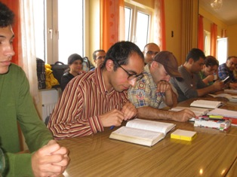 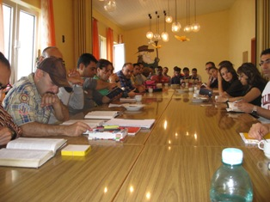 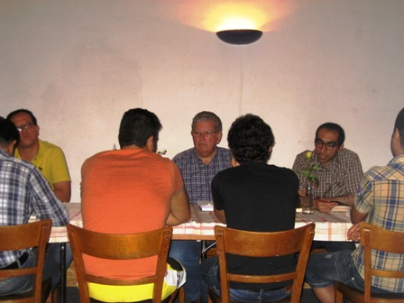
In addition, it is possible that, as we work with "Café Hope", we will also minister to other language groups by meeting at other times during the week to share the Gospel and explain the uniqueness of Jesus. It is also probable that we'll share the Gospel during the "Café Hope" weekly Gospel presentation. Last year we spent six weeks in Giessen (see pics above), but this year we will spend at least two months or a little more there in order to make best use of our time and get the most "bang for the buck".

After we had made the decision to return to Giessen, we were invited by Richard and Stephanie Blake to join them in teaching at the Yangon Grace Bible School in Yangon, Burma (Myanmar) in mid October. We will go directly from Germany to Burma rather than take two separate trips. Our assignment there is to help train the students from around the country who have come to the school to be equipped for sharing the Gospel and planting churches in their predominantly Buddhist country. Richard has recently become the President of the school and describes the strategic nature of the school in one of his recent blogs. We have included it so you can get a better picture of our potential role: http://xtendinternational.com/?page_id=568.

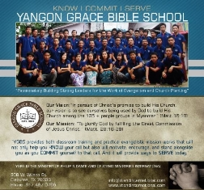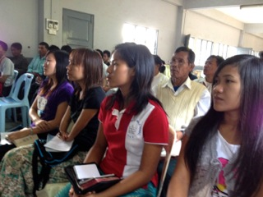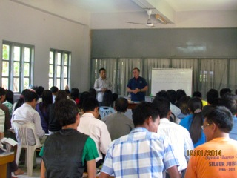

Needs For The Trip:

Surprisingly, even with the addition of the Myanmar leg of the trip, our costs will remain nearly the same. Last year our budget was $19,700, and we spent slightly over $20,000. The anticipated budget for this upcoming trip is $20,170. We have broken it down into three segments ----
Medical and Emergency Evacuation Insurance for Entire Trip ---- $2,400 ($800 per month.)
Germany portion of Trip (air travel, apt rent, food, min. exp, etc. ---- $12,840 (for 10 weeks)
Myanmar portion of Trip (air travel, hotel rent, food, min exp, etc. ---- $4,930 (for two weeks)

We have long exhausted our personal resources, so depend on those who feel God wants them to be part of this ministry. Please pray about this need. We are already well past the time we should have secured our airline tickets, so ask you to seek the mind of the Lord quickly. Our most urgent need of the moment is $6,800 to enable us to purchase both sets of airline tickets. Most of the rest needs to come by mid to late July. If you would like a more detailed breakdown of the budget, please let us know and we can e-mail it to you.

Dates of the Trip:

A number of factors are involved in setting the exact dates of the trip, but we are planning on departing between July 30 and August 6, and returning between October 23 and 30. As is always the case, 100% of what is given, goes specifically to that which was designated, and because Life Unlimited Ministries is a 501.c.3 ministry, all gifts are deductible as a contribution on tax returns. And, as last year, we will provide a full accounting upon the conclusion of the trip.

If you are able to share in this ministry venture, please let us know as soon as possible . . . either by sending a check made out to Life Unlimited Ministries with "Germany/Myanmar Trip" on the memo line, or by letting us know what you plan to give before the end of July.

In His Bond, By His Grace, and For His Gospel,
Send any checks to Life Unlimited Ministries, Box 228, Collins, MO 64738. If you need to contact us, e-mail us at lifeunlimited@pobox.com. Cell phone is 417-693-5149 OR 417-693-5313.

Bob and Jo Ann, the Tollivers

