Vitamin D and COVID
Vitamin D’s role:
Vitamin D deficiency has been associated with a number of pathologic conditions including infections, autoimmune and allergic disease. It is actively involved in the regulation of innate and adaptive immune responses. It signals through the vitamin D receptor (VDR), a specific zinc-finger nuclear receptor. This has effects both at the genomic level (through a transcriptional effect inside the cell nucleus) and non-genomic level (it induces rapid signaling on the cell membrane through the VDR). There continues to be emerging evidence that it enhances immunity, providing protection from pathogens, while concomitantly exerting an immunosuppressive effect by preventing the detrimental effect of prolonged inflammatory responses to the host¹. Furthermore, respiratory monocytes/macrophages and epithelial cells constitutively express the vitamin D receptor², as do antigen-presenting cells, T cells and B cells⁴. It is the active form of calcitriol and not 25-hydroxyVitD that appears to be important in immune-modulation³.
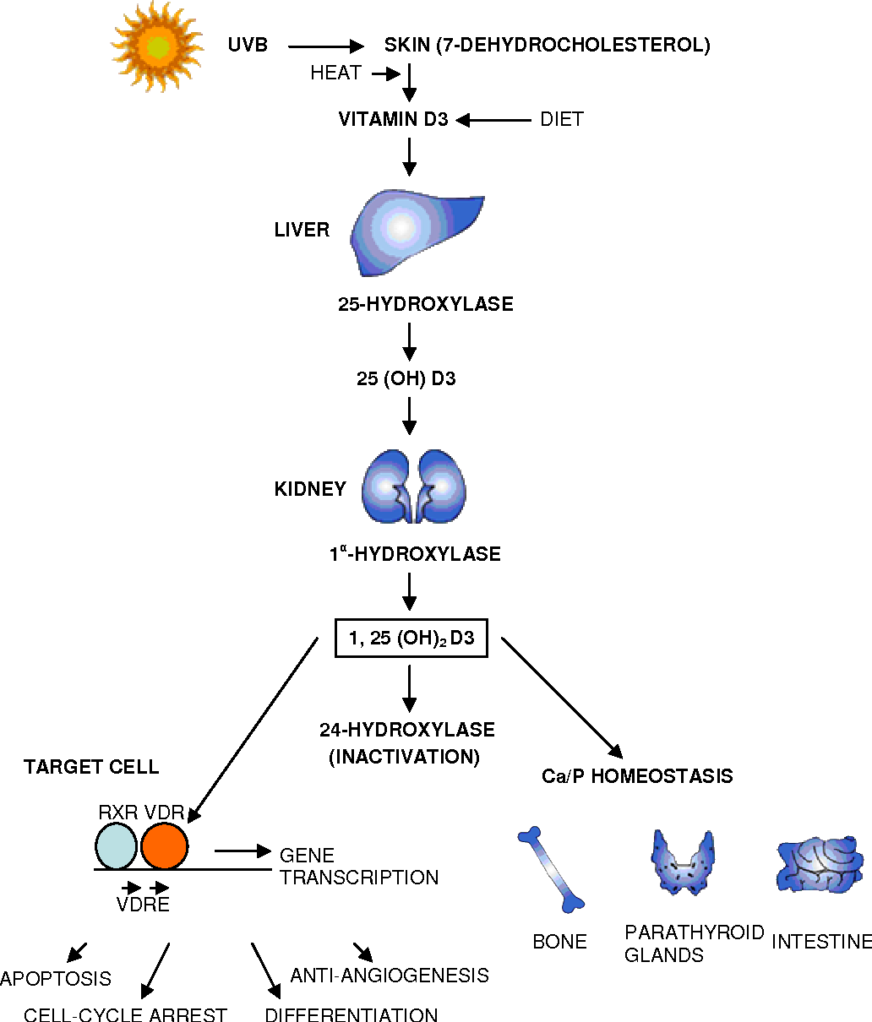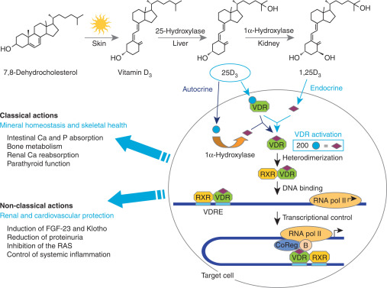
Other proposed mechanisms by which vitamin D is thought to work include inducing cathelicidins and defensins (antimicrobial peptides found in the respiratory epithelium) that lower viral replication rates and reduce concentrations of pro-inflammatory cytokines that produce the inflammation that injures the lining of the lungs leading to pneumonia, as well as increasing concentration of anti-inflammatory cytokines⁵. There have been observational studies and clinical trials where vitamin D supplementation was noted to reduce the risk of influenza⁶. Furthermore, deficiencies have been found to contribute to acute respiratory distress syndrome. Case-fatality rates increase with age and with chronic disease. This has been seen with COVID as well^{7,8}.
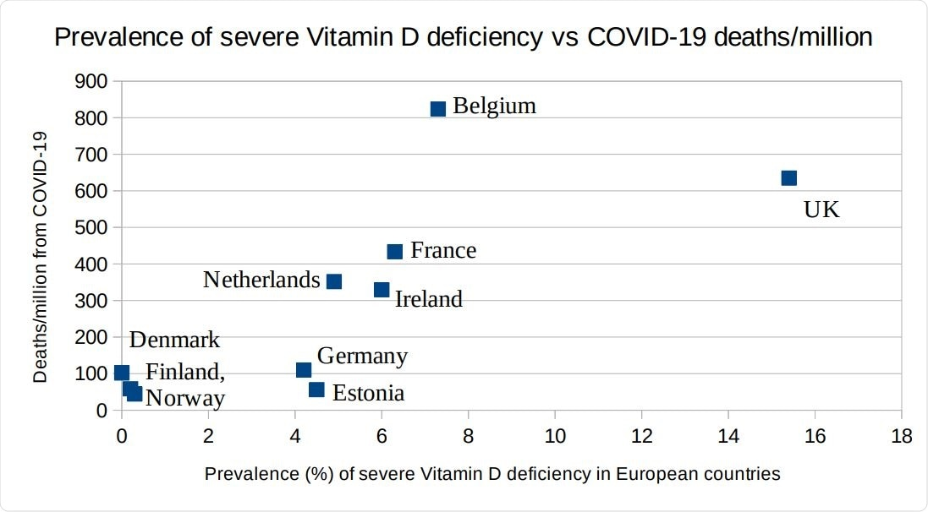
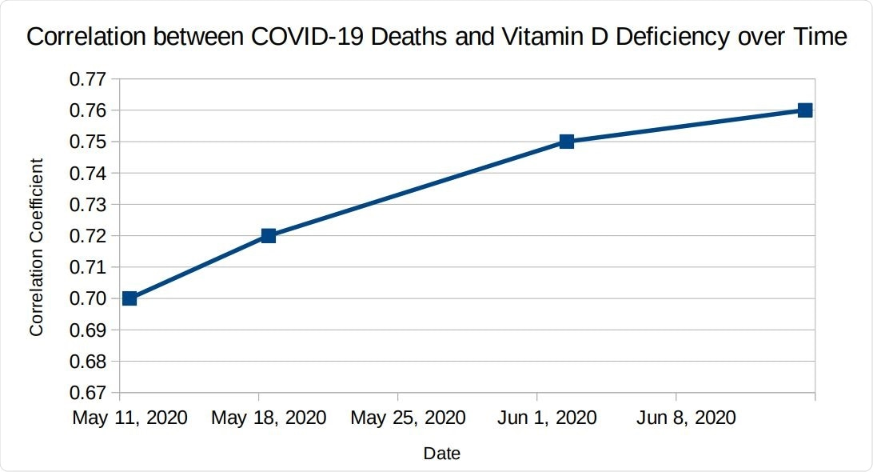
In conclusion, there are many who recommend universal screening for vitamin D deficiency, and further investigation of supplementation in randomized control studies should be performed⁸.
Deficiency: The goal should be to raise 25(OH)D concentrations above 40-60 ng/ml (100-150 nmol/L). Normal levels are between 20-50 ng/ml. If infected with COVID-19, higher vitamin D3 doses might be helpful.

Supplement: For most people the recommended daily allowance (RDA) is 600 IU/day, or 800 for those over age 70. There are no 600 IU tablets, so can take 1,000 IU five times per week.

References :
- Vitamin-D in the immune system: Genomic and Non-genomic actions. Mini Rev Med Chem. 2015;15(11):953-63
- Vitamin D modulation of innate immune responses to respiratory viral infections. Rev Med Virol 2017 Jan;27(1)
- Modulation of inflammatory and immune responses by vitamin D. J Autoimmun. 2017 Dec;85:78-97
- Vitamin D and immune function. Nutrients. 2013 Jul 5;5(7):2502-21.
- The possible role of Vitamin D in suppressing cytokine storm and associated mortality in COVID-19 patients medRxiv preprint doi: https://doi.org/10.1101/2020.04.08.20058578
- Vitamin D and influenza- Prevention or Therapy? Int J Mol Sci. 2018 Aug; 19(8):2419
- Association of vitamin D deficiency and treatment with COVID-19 incidence. medRxiv preprint doi: https://doi.org/10.1101/2020.05.08.20095893
- Correlation Between Prevalence of Severe Vitamin D Deficiency and Population Mortality Rate from COVID-19 in Europe. medRxiv 2020. doi: https://doi.org/10.1101/2020.06.24.20138644

